Create a simple cloud software application for Library book reservation system for SIMATS library using any Cloud Service Provider to demonstrate SaaS

Aim
To create a simple cloud-based Library Book Reservation System for SIMATS Library using Zoho Creator to demonstrate the SaaS model.
Procedure
- Login to Zoho Creator and create an application named SIMATS Library Management System.
- Create a Book Details form with Book ID, Book Name, Author, Department, Category, and Availability.
- Create a Student Details form with Student ID, Student Name, Department, Year, and Contact Number.
- Create a Book Reservation form with Student ID, Book ID, Reservation Date, and Status.
- Add a workflow to check whether the selected book is available.
- Update the book status automatically as Available, Reserved, or Issued.
- Create a Book Issue/Return form to record issue and return dates.
- Create reports for available books, reserved books, issued books, and returned books.
- Create a dashboard for librarians to monitor books and reservations.
- Test and deploy the application through the cloud so students and library staff can access it online.

Result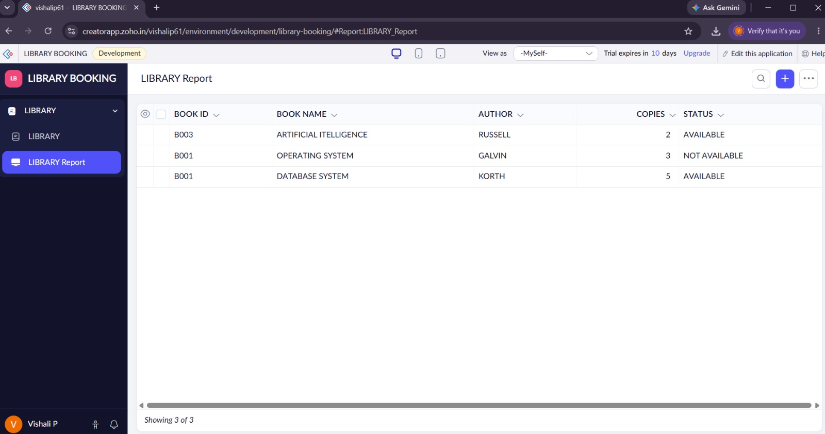
A cloud-based SIMATS Library Book Reservation System was successfully created using Zoho Creator and demonstrated as SaaS.

